**TOPIC:**

**FILTER SPECIFICATIONS AND HOW TO DESIGN A DIGITAL FILTER BASED ON THE GIVEN SPECIFICATIONS.**

**STUDENT ID: 201314060110**



**NAME: EUGENE OPOKU – MENSAH**

**PHD COMPUTER SCIENCE**

Table of Contents

ABSTRACT 3

INTRODUCTION 3

DIGITAL FILTER DESIGN CONSIDERATIONS 5

SELECTION OF FILTER TYPE 9

FIR DIGITAL FILTER DESIGN: BASIC APPROACHES 10

IIR FILTER DESIGN 11

Most Common Approach to IIR Filter Design 11

STEPS IN THE DESIGN OF IIR HIGHPASS, BANDPASS, AND BANDSTOP DIGITAL FILTERS 13

SPECTRAL TRANSFORMATIONS 14

LOWPASS TO LOWPASS SPECTRAL TRANSFORMATION 14

CONCLUSION 15

REFERENCES 17

# ABSTRACT

Filters can be built in a number of different technologies. Often the components in different technologies are directly analogous to each other and fulfill the same role in their respective filters. Filtering operations include Noise suppression, Enhancement of selected frequency ranges, Band limiting etc. Finite impulse response filters are highly desirable in digital filter design because of their inherent stability and linear phase. However, when narrow transition band characteristics are required, they typically have a much higher filter order than their infinite impulse response counterparts with equivalent magnitude spectrums. This paper will investigate the specifications and the method to design a digital filter based on the given specifications**. Infinite impulse response** (IIR) **digital filter design** will be of particular interest since they typically meet a given set of specifications with a much lower filter order than a corresponding FIR filter. Moreover, order of an FIR filter in most cases is considerably higher than the order of an equivalent IIR filter meeting the same specifications, and FIR filter has thus higher computational complexity.

# INTRODUCTION

Digital Filter is a numerical procedure or algorithm that transforms a given sequence of numbers into a second sequence that has some more desirable properties. In [signal processing](http://en.wikipedia.org/wiki/Signal_processing), a **filter** is a device or process that removes from a [signal](http://en.wikipedia.org/wiki/Signal_%28electronics%29) some unwanted component or feature. Filtering is a class of signal processing, the defining feature of filters being the complete or partial suppression of some aspect of the signal. Most often, this means removing some [frequencies](http://en.wikipedia.org/wiki/Frequency) and not others in order to suppress interfering signals and reduce background [noise](http://en.wikipedia.org/wiki/Signal_noise). However, filters do not exclusively act in the [frequency domain](http://en.wikipedia.org/wiki/Frequency_domain); especially in the field of [image processing](http://en.wikipedia.org/wiki/Image_processing) many other targets for filtering exist. The drawback of filtering is the loss of information associated with it. [Signal combination](http://en.wikipedia.org/wiki/Noise_reduction) in Fourier space is an alternative approach for removal of certain frequencies from the recorded signal. There are many different bases of classifying filters and these overlap in many different ways; there is no simple hierarchical classification. Filters may be: [analog](http://en.wikipedia.org/wiki/Analogue_filter) or [digital](http://en.wikipedia.org/wiki/Digital_filter), [discrete-time](http://en.wikipedia.org/wiki/Discrete-time) (sampled) or [continuous-time](http://en.wikipedia.org/wiki/Continuous_signal),[linear](http://en.wikipedia.org/wiki/Linear_filter) or [non-linear](http://en.wikipedia.org/wiki/Non-linear_filter),[time-invariant](http://en.wikipedia.org/wiki/Time-variant_system) or [time-variant](http://en.wikipedia.org/wiki/Time-variant_system), also known as shift invariance, [passive](http://en.wikipedia.org/wiki/Passive_component) or [active](http://en.wikipedia.org/wiki/Active_filter) type of continuous-time filter, [infinite impulse response](http://en.wikipedia.org/wiki/Infinite_impulse_response) (IIR) or [finite impulse response](http://en.wikipedia.org/wiki/Finite_impulse_response) (FIR) type of discrete-time or digital filter.

A key element in processing digital signals is the filter. Filters perform direct manipulations on the spectra of signals. To completely describe digital filters, three basic elements (or building blocks) are needed: **an adder, a multiplier, and a delay element**. The adder has two inputs and one output, and it simply adds the two inputs together. The multiplier is a gain element, and it multiplies the input signal by a constant. The delay element delays the incoming signal by one sample. Digital filters can be implemented using either a block diagram or a signal flow graph.With the basic building blocks at hand, the two different filter structures can easily be implemented based on given specifications. These two structures are Infinite Impulse Response (IIR) and Finite Impulse Response (FIR), depending on the form of the system’s response to a unit pulse input. IIR filters are commonly implemented using a feedback (recursive) structure, while FIR filters usually require no feedback (non-recursive).An important step in the development of a digital a digital filter is the determination of a realizable transfer G(z) approximating the given frequency response specifications. If an IIR filter is desired, it is also necessary to ensure that G(z) is stable. The process of delivering the transfer function G(z) is called digital filter design. After G(z) has been obtained, the next step is to realize it in the form of suitable filter structure. Two major issues need to be answered before one can develop the digital transfer function G(z). These are the development of a reasonable filter frequency response specification from the requirement of the overall system in which the digital filter is to be employed and to determine whether FIR or IIR digital filter is to be determined. In the design of IIR filters, a commonly used approach is called the **bilinear transformation**. This design begins with the transfer function of an analog filter, and then performs a mapping from the s-domain to the z-domain. There is an alternative method for designing IIR digital filters that is **spectral transformation**. It replaces the analog frequency transformation by a frequency transformation in the digital domain. Basic elements of a digital filter is shown below.

**ELEMENTS OF A DIGITAL FILTER**



**Positive delay (“delay”):**

Stores the current value for one sample interval

$$Z^{-1}$$

$$y_{n}=x_{n}-1$$

$$x_{n}$$

**Negative delay (“advance”):**

Allows to look ahead, e.g. image processing

$$Z$$

$$y_{n}=x_{n}+1$$

$$x_{n}$$

Fig. 1: Block Diagram of Filter Elements



Fig. 2: Signal Flow Graph of Filter Elements

# DIGITAL FILTER DESIGN CONSIDERATIONS

Digital filter design is the process of deriving the transfer function *G*(*z*) Usually, either the magnitude and/or the phase (delay) response is specified for the design of digital filter for most applications. The basic considerations involved in digital filter design include the following:

1. Specification of the filter’s response,

2. Design of transfer function of the filter,

3. Verification of the filter’s performance by, analytic means, simulations and testing with real data if possible,

4. Implementation by hardware / software (or both).

**DIGITAL FILTER SPECIFICATIONS**

In most practical applications, the problem of interest is the development of a realizable approximation to a given magnitude response specification. Basically, there are four types of ideal filters with magnitude response as shown below:



Fig. 3: Types of ideal filters with magnitude response

As the impulse response corresponding to each of these ideal filters is noncausal and of infinite length, these filters are not realizable. In practice, the magnitude response specifications of a digital filter in the passband and in the stopband are given with some acceptable tolerances. In addition, a transition band is specified between the passband and stopband. Another perspective that provides some understanding can be obtained by looking at the ideal amplitude squared. When designing a filter, there is always an end goal in mind that has certain specifications. There are several methods for determining the minimum length a filter needs to be to meet these given specifications. However, these are called estimations for a reason because they do not always provide the correct filter order. The smallest integer value that lies above the estimation should be checked for accuracy after the implementation. For example, the magnitude response |G(ejω)| of a digital lowpass filter may be given as in figure 4. As indicated in the figure, in the passband, defined by 0≤ω≤ωp, we require that |G(ejω)|≅1 with an error ±δp, i.e.,

1- δp ≤ |G(ejω)| ≤ 1+ δp, | ω| ≤ ωp

In the stopband, defined by ωs ≤ω≤π, we require that |G(ejω)|≅0 with an error δs

i.e., |G(ejω)| ≤ δs, ωs ≤|ω|≤π

The parameters given include normalized passband edge angular frequency ωp, normalized stopband edge angular frequency ωs, peak passband ripple δp, and peak stopband ripple δs. Now, the frequency response G(ejω) is a periodic function of ω, and the magnitude response of a real-coefficient digital filter is an even function of ω. As a result, filter specifications are given only for the frequency range 0 ≤|ω|≤π . Often, digital filter specifications are given in terms of loss function G(ω)=-20log10 |G(ejω)| in dB Peak passband ripple αp= -20log10 (1- δp ) dB. Minimum stopband attenuation αs= -20log10 (δs ) dB

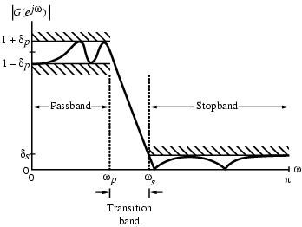

Fig. 4: Magnitude Specifications for a Digital Lowpass Filter

Now, the specifications for a digital lowpass filter may alternatively be given in terms of its magnitude response, as in figure 5. Here, the maximum value of the magnitude in the passband is assumed to be unity, and the maximum passband deviation, denoted as 1/√(1+ε2) , is given by the minimum value of the magnitude in the passband. The maximum stopband is denoted by 1/A. For the normalized specification, the maximum value of the gain function or the minimum value of the loss function is therefore 0dB. The quantitygiven is called the minimum passband attenuation. For δp<<1, it can be shown that

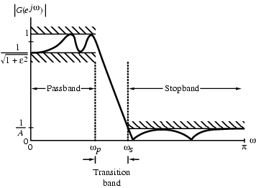

Fig. 5: Alternate magnitude specifications for a digital lowpass filter

The passband and stopband edge frequencies, in most applications, are specified in Hz, along with the sampling rate of the digital filter. Since all filter design techniques are developed in terms of the angular frequencies ωp and ωs, the specified critical frequencies need to be normalized before a specific filter design algorithm can be applied. In practice, passband edge frequency Fp and stopband edge frequency Fs are specified in Hz. For digital filter design, normalized band edge frequencies need to be computed from specifications in Hz. Using:



# SELECTION OF FILTER TYPE

The transfer function H(z) meeting the frequency response specifications should be a causal transfer function. For IIR digital filter design, the IIR transfer function is a real rational function of z-1**:**.

H(z) must be a stable transfer function and must be of lowest order N for reduced computational complexity. For FIR digital filter design, the FIR transfer function is a polynomial in z-1 with real coefficients:**.** For reduced computational complexity, degree N of H(z) must be as small as possible. If a linear phase is desired, the filter coefficients must satisfy the constraint: h[n] = ± h[N-n]

With recursive IIR filters, we can generally achieve a desired frequency response characteristic with a filter of lower order than for a non-recursive filter (especially if elliptic designs are used). A recursive filter has both poles and zeroes which can be selected by the designer, hence there are more free parameters than for a non-recursive filter of the same order (only zeroes can be varied). However, when the poles of an IIR filter are close to the unit circle, they need to be specified very accurately (typically 3 to 6 decimal places) if instability is to be avoided.

# FIR DIGITAL FILTER DESIGN: BASIC APPROACHES

FIR filter design is based on a direct approximation of the specified magnitude response, with the often added requirement that the phase be linear. The design of an FIR filter of order N may be accomplished by finding either the length-(N+1) impulse response samples {h[n]} or the (N+1) samples of its frequency response H(ejω). Three commonly used approaches to FIR filter design are:

(1) Windowed Fourier series approach

(2) Frequency sampling approach

(3) Computer-based optimization methods

**Advantages in using an FIR Filter**

1) Can be designed with exact linear phase,

2) Filter structure is always stable with quantized coefficients.

**Disadvantages in using an FIR Filter**

Order of an FIR filter, in most cases, is considerably higher than the order of an equivalent IIR filter meeting the same specifications, and FIR filter has thus higher computational complexity.

# IIR FILTER DESIGN

## Most Common Approach to IIR Filter Design

1. Convert the digital filter specifications into an analog prototype lowpass filter specifications

2. Determine the analog lowpass filter transfer function Ha(s)

3. Transform Ha(s) into the desired digital transfer function G(z)

This approach has been widely used for the following reasons:

(a) Analog approximation techniques are highly advanced

(b) They usually yield closed-form solutions

(c) Extensive tables are available for analog filter design

(d) Many applications require digital simulation of analog systems

**Bilinear Transformation:**

The above transformation maps a single point in the s-plane to a unique point in the z-plane and vice-versa. Relation between G(z) and Ha(s) is then given by:



. Bilinear transformation digital filter design consists 3 steps:

1. Develop the specifications of Ha(s) by applying the inverse bilinear transformation to specifications of *G*(*z*)

2. Design Ha(s)

3. Determine *G*(*z*) by applying bilinear transformation to Ha(s)

As a result, the parameter T has no effect on *G*(*z*) and T = 2 is chosen for convenience. The inverse bilinear transformation for T=2 is

For



And so,

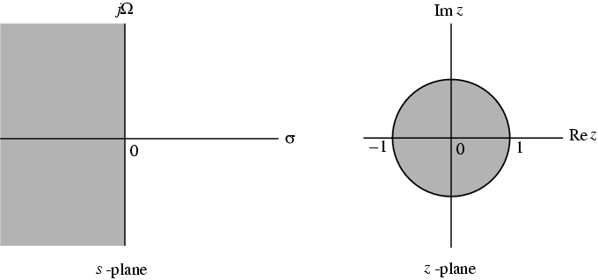

Fig. 7: Mapping of the s-plane into the z-plane



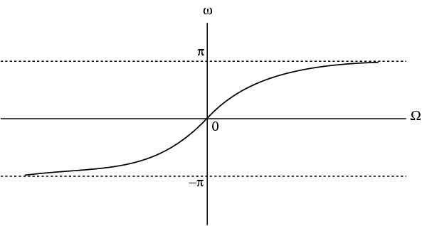

Fig. 8: Mapping of the angular analog frequency to the angular digital frequencies via the bilinear transformation.

## STEPS IN THE DESIGN OF IIR HIGHPASS, BANDPASS, AND BANDSTOP DIGITAL FILTERS

Transformation can be used only to design digital filters with prescribed magnitude response with piecewise constant values. Transformation does not preserve phase response of analog filter.

**First Approach**:

1. Prewarp digital frequency specifications of desired digital filter GD(z) to arrive at frequency specifications of analog filter HD(s) of same type

2. Convert frequency specifications of HD(s) into that of prototype analog lowpass filter HLP(s)

3. Design analog lowpass filter HLP(s)

4. Convert HLP(s) into HD(s) using inverse frequency transformation used in Step 2

5. Design desired digital filter GD(z) by applying bilinear transformation to HD(s)

**Second Approach:**

1. Prewarp digital frequency specifications of desired digital filter GD(z) to arrive at frequency specifications of analog filter HD(s) of same type

2. Convert frequency specifications of HD(s) into that of prototype analog lowpass filter HLP(s)

3. Design analog lowpass filter HLP(s)

4. Convert HLP(s) into an IIR digital transfer function GLP(z) using bilinear transformation

5. Transform GLP(z) into the desired digital transfer function GD(z)

# SPECTRAL TRANSFORMATIONS

To transform a given lowpass transfer function to another transfer function that may be a lowpass, highpass, bandpass or bandstop filter, has been used to denote the unit delay in the prototype lowpass filter  and  to denote the unit delay in the transformed filter  to avoid confusion.













## LOWPASS TO LOWPASS SPECTRAL TRANSFORMATION

To transform a lowpass filter with cut-off frequency to another lowpass filter with cut-off frequency, the transformation is:



,

which has a passband from dc to with a 0.5 dB ripple and redesigning the above filter to move the passband edge to.



**Gain, dB**

0

0.2

0.4

0.6

0.8

1

-40

-30

-20

-10

0

****

/

****

G

L

(z)

G

D

(z)

# CONCLUSION

From the explanation and design specifications above, it is seen that both FIR and IIR can be realized if their design specifications are provided. It could to be pointed out that the constant group delay of analog filters does not transform to a constant group delay of the IIR filter obtained by the bilinear transformation. Using the poles and zeros of a classical lowpass prototype filter in the continuous (Laplace) domain, we obtained a digital filter through frequency transformation and filter discretization. The specifications and design method described in this paper is basically geared towards the design of IIR digital filter, since the primary advantage of IIR filters over FIR filters is that they typically meet a given set of specifications with a much lower filter order than a corresponding FIR filter. Although IIR filters have nonlinear phase,

Today, many DSP application specific platforms are available along with development systems for the savvy engineer, who wishes to do his or her own design. Many computer programs also exist that can determine the number of taps and the values of computation coefficients that are required to implement a specific digital filter performance function. MATLAB software is commonly used in this respect. This allows for a non-causal, zero-phase filtering approach, which eliminates the nonlinear phase distortion of an IIR filter. Because of the many hardware and software design options and trade-offs available in providing signal processing solutions, having the availability of analog and DSP design and programming expertise along with the specific application design can provide a strong to the busy design engineer to configure a Frequency Devices according to the need.

Examples include:

* Multi-Rate FIR filters, which can significantly extend low frequency bandwidth limits and shorten filter delay
* AD and DA signal converters with -100 dB or better noise floors.

As DSP sample rates continue to increase, the bandwidth and performance of DSP solutions will also increase.

# REFERENCES

[1] Y. Neuvo, C. Dong, and S.K. Mitra, “*Interpolated finite impulse response filters,”* in IEEETransactions on Acoustics, Speech, and Signal Processing*,*vol. 32, no. 3, pp. 563-570, June 1984.

[2] http://www.mathworks.com/help/toolbox/signal/f4-1046.htm.

[3] Sanjit .K. Mitra, *Digital Signal Processing: A Computer Based Approach*, 7nd Edition McGraw Hill 2000.12, pages 423-498.

[4] A.G. Constantinides, An *introductory lecture to Digital Signal Processing & Digital Filters,* Imperial College London, 2007.

[5] Dzhankhotov V., *Hybrid LC filter for power electronic drives: Theory and Implementation*, 2009.

[6] Matthaei, Young, Jones *Microwave Filters, Impedance-Matching Networks, and Coupling Structures* McGraw-Hill 1964

[7] Zverev, Anatol, I (1969). *Handbook of Filter Synthesis. John Wiley & Sons*. [ISBN](http://en.wikipedia.org/wiki/International_Standard_Book_Number) [0-471-98680-1](http://en.wikipedia.org/wiki/Special:BookSources/0-471-98680-1). Catalog of passive filter types and component values. The Bible for practical electronic filter design.

[8] Williams, Arthur B & Taylor, Fred J (1995). *Electronic Filter Design Handbook*. McGraw-Hill. [ISBN](http://en.wikipedia.org/wiki/International_Standard_Book_Number) [0-07-070441-4](http://en.wikipedia.org/wiki/Special:BookSources/0-07-070441-4).

[9] Lecture 6 - Design of Digital Filters www.robots.ox.ac.uk/~sjrob/Teaching/SP/l6.pdf

[10] Frequency Devices Inc. FIR and IIR Digital Filter Design Guide . www.freqdev.com/**guide**/DgtlFltrDsgnGd.pdf